**New requirement**

Migrate some function from current ui to job_finder ui (I will provide the job_finder source code to u)

* Must follow the db I given (similar with current version)
* Register
* Login
* Admin
* Create job function (job status… same as the current system)
* View job
* Profile function
* Comment and rating function
* Home page
* Reset password function
* Chat function
* No need migrates the push notification function

-Register (separate the seeker and provider register page)

-Login (separate the seeker and provider login page)

-Admin

remove seeker and post service admin approval, seeker registration and post service no need admin to approve direct can register and post the ads,

admin can only block or unblock the seeker, service to inactive,

remain provider registration is need admin approval,

remain admin can block, unblock, the provider,

admin page still want to display all seeker, service post, provider information

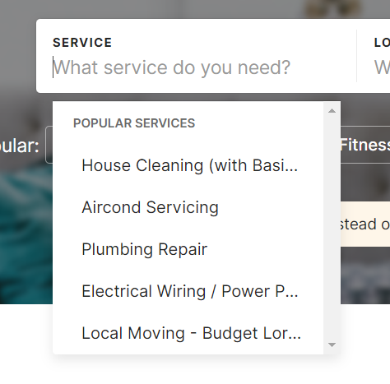

For the seeker create new job post, the job category can’t manually type by the user, when user inserting job category, the system need to provides the job category dropdown list for user to choose to make sure the system’s job category is consistent, example is given above. Therefore, this I open another db to store the job-category must.